ubiquitous learning applications on top of iconographic digital library

Radoslav Pavlov†, Desislava Paneva†, Lilia Pavlova-Draganova‡, Lubomil Draganov†
† Institute of Mathematics and Informatics – Bulgarian Academy of Sciences, Sofia, Bulgaria
‡ Laboratory of Telematics – Bulgarian Academy of Sciences, Sofia, Bulgaria
{radko, dessi, lilia, lubo} @ cc.bas.bg

Abstract
The emergence of knowledge society signifies a new era for education and training i.e. ubiquitous learning. Ubiquitous learning aims at replacing old-fashioned time/place/content-predetermined learning with a just-in-time/at work-place/customized/on-demand process of learning. A strategy for achieving this is provisioning service-based platforms for cross-media learning content authoring, access, delivery, study and assessment through different modes and levels of integrated communication spaces (Web, DVB, mobile phones) obtaining digital knowledge from large-scale repositories (digital libraries, archives). These ideas are being developed in the project LOGOS Knowledge-on-Demand for Ubiquitous Learning that contributes to the openness for ubiquitous learning of the large-scale repositories of digitised text, graphics, audio, video objects and to the process of their transformation into learning content, adequately enhancing and facilitating the process of the knowledge building. This paper presents the architecture of the LOGOS Repositories and Authoring Studio, based on the special usage scenarios. The Access-on-demand for studying of East-Christian culture and art scenario has been included, which was developed for a range of users both attached and unattached to formal educational programmes. The scenario has four variants according to the learning situation and the communication channels. The knowledge source is the Virtual encyclopaedia of Bulgarian iconography multimedia digital library. Finally, the paper describes the Bulgarian iconographical objects ontology that targets semantic annotation and indexing of digital objects (extracted from the mentioned digital library) used for the courseware creation in the field of Bulgarian iconography.

Keyword
ubiquitous learning, digital libraries, Bulgarian iconography

- introduction
The main idea of the LOGOS project “Knowledge-on-Demand for Ubiquitous Learning” (http://logosproject.com/) is the implementation of knowledge-on-demand ubiquitous learning by taking valuable digitized information from existing large-scale repositories (viz. digital archives, digital libraries), transforming it by specialized Authoring studio into learning content and delivering it by different channels (integrated web-, digital television and mobile technologies) to the users. This paper presents the work that is being done by the team from the Institute of Mathematics and Informatics at the Bulgarian Academy of Sciences (IMI-BAS) and its partners for realizing the ubiquitous learning paradigm in the LOGOS project.
This paper begins with description of main aims and tasks of the project and the architecture of its authoring studio and repositories (section 2). Section 3 presents the ubiquitous learning scenario, named “Access-on-Demand for Studying East-Christian Culture and Art” that is developed on the basis of the use of the LOGOS learning platform and the content of its knowledge repository - “Virtual Encyclopaedia of Bulgarian Iconography” multimedia digital library (http://mdl.cc.bas.bg). The scenario traces several learning situations for learning content provision to wide range of students using different knowledge delivery channels. Section 4 describes the “Ontology of Bulgarian Iconographical Objects”, considering iconography art objects registered within the “Virtual Encyclopaedia of Bulgarian Iconography”. The ontology targets semantic annotation and search of digital objects that will be used for creation of learning and courseware materials in the field of Bulgarian iconography according to the included LOGOS learning scenario. The ontology is a product of the close cooperation between Institute of Information Technologies Informatics at the Bulgarian Academy of Science and IMI-BAS.

- LOGOS project: “knowledge-on-demand for ubiquitous learning”
The LOGOS project contributes to the openness for ubiquitous learning of the large-scale repositories of digitised text, graphics, audio, video objects and to the process of their transformation into learning content, adequately enhancing and facilitating the knowledge building. The project addresses innovative development of the main components of the learning processes – resources, services, communication spaces. New functionality of the learning communication spaces will be achieved by integrated web-, digital television and mobile technologies, supporting cross-media learning content. New eLearning management systems based on this integration will improve and extend the learning services within new consistent pedagogical scenarios. The use of annotated and adequately structured knowledge from digital archives will enable lecturers/authors to participate in ‘open source’ content development from massive, dynamically growing learning resources.
The project is targeted at the following results: 1/ Development of learning scenarios for ubiquitous learning in different learning contexts, modelling learning process and learning materials by considering different ways and phases of cross-media authoring, access, delivery, study and assessments through different modes and levels of integrated web-based, DVB and mobile technologies; 2/ Development of authoring studio for generation of learning resources from existing digital archives; 3/ Development and implementation of knowledge-on-demand ubiquitous learning platform, integrating learning resources and communication spaces through knowledge-on-demand learning services; 4/ Extended experimentation of the functionality and usability of the platform implementation by authors/lecturers and learners in multiple national contexts. The project meets the challenges of Europe enlargement by its research and development to provide highly customizable knowledge-on-demand learning services for the broad public in ubiquitous manner.

Architecture of the LOGOS authoring studio
The architecture of the LOGOS authoring studio is developed by the project partners from the Technical University of Crete (Greece), Institut National de l’Audiovisuel, University of Montpelier, University of Angers (France), Institute for Information Technologies at the Bulgarian Academy of Sciences (IIT-BAS), EduWeb Multimedia Co., Budapest University of Technology and Economics (Hungary), etc.
The Authoring Studio tools support the user tasks related to the identified user roles communicate with the LOGOS repositories to access and maintain digital objects (DOs), learning objects (LOs), courseware objects (COs).
The different types of objects along with their relationships are depicted in figure 1.

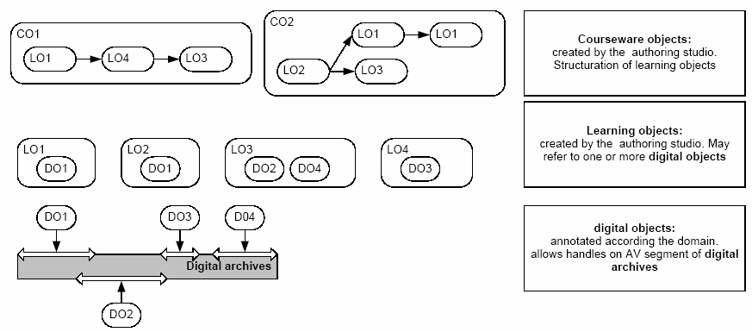
Figure 1: Stack of objects managed by the LOGOS repositories
DOs are segments of audiovisual objects or whole objects of other media types appropriately annotated and semantically indexed that will be main components of the LOGOS learning materials. Learning objects are independent and self-standing units of learning content that are predisposed to reuse in multiple instructional contexts. LOs are collections of DOs enriched with educational metadata. They are the minimal objects that can be re-used for the creation of COs. Courseware objects are structured objects that can be used to provide individual (personalized) or collective learning experiences in formal, non-formal on informal learning settings. They are hierarchies of LOs (usually along with sequencing metadata). CO creation may be realized by following a manual (static) approach or a personalized (automatic) approach. Automatically created COs may be further edited, thus providing a semi-automatic approach to courseware creation.
The three types of objects are handled by the three corresponding LOGOS Repositories (illustrated in Figure 2):
- The Digital Objects Repository will handle DOs providing a set of services (in the form of web services) for their management.
- The Learning Objects Repository will handle LOs providing a set of services (in the form of web services) for their management.
- The Courseware Objects Repository will handle COs providing a set of services (in the form of web services) for their management.

Figure 2: LOGOS Repositories and their relationships
The Digital objects repository, where digital objects are stored and described using METS pointing to MPEG7 (administrative) and Conceptual Graph (semantic) descriptions. This repository references media objects that reside in a Media Server. The Media server is used to store media objects coming from external content archives and builds a searchable catalogue of these objects. The Learning objects repository, where learning objects are stored and described using METS pointing to LOM (Learning Object Metadata, educational metadata) and underlying METS descriptions of DOs that constitute the LOs pointing to MPEG7 (administrative) and Conceptual Graph (semantic) descriptions. Some important elements that should be used in the LOM descriptions are: educational objectives expressed as {verb (Bloom’s Taxonomy (Bloom & Krathwohl, 1965)+subject (term from a domain ontology or conceptual graphs to facilitate the representation of complex semantic structures)} using the classification part of LOM, context, typicalAgeRange and difficulty. (Arapi et al. (2007))
- The Middleware, which is responsible a) for the assembly of personalized learning experiences and b) for the transformation of the METS descriptions to SCORM packages. The middleware consists of the following parts:
  - The METS/SCORM transformation component, which is responsible for the transformation of the METS descriptions to SCORM Content Packages. This includes simple transformation from METS XML file to SCORM manifest file as well as the construction of the whole SCORM package (PIF - Package Interchange File). Moreover, the mime-type of the files is taken into account and, if needed, intermediate html pages are constructed with links to these files (e.g. in case of video files).
  - The Personalized learning experiences assembler (PALEA), which, taking into account the information provided by the learning designs (abstract training scenarios) and the learner profiles, constructs the personalized learning experiences and delivers them in the form of SCORM Packages. The resulted learning experience is stored in the courseware repository, being ready and available in an interoperable way for later requests. (Arapi et al. (2007))
The Courseware objects repository, where learning experiences are stored in SCORM format (manifest files + LOM metadata + resources). These learning experiences can be manually constructed (e.g. a Courseware developer uses the authoring studio or another learning content management system (LCMS) to construct them) or dynamically (a learner requests a learning experience that fits to his needs), where PALEA component is used for the generation of the learning experience. Learning designs database maintains abstract training scenarios in a certain domain built according to the model given in a certain instructional ontology. The instructional ontology provides a model for the construction of abstract training scenarios. These are pedagogical approaches (instructional strategies/didactical templates), which can be applied to the construction of learning experiences. The Learner profiles database, where the learner profiles are stored. Elements from IEEE PAPI (IEEE PAPI, (2002)) and IMS LIP (IMS LIP (2005)) specifications can be used to construct an appropriate learner profile model, but other important elements should be also added like learner goals, competencies, previous knowledge, educational level and learning style. The structure and contents of learner profiles should be decided by the WP4 implementation partners as well as the minimum services that should be offered from the learner profiles database to WP3.
The main LOGOS authoring studio tools are Ontology management tool, Graphical conceptual graph querying tool, Navigation-based information retrieval tool, Content description tool, Description tool for learning objects, Learning designs editor, Courseware objects editor and Publishing tool. A short overview of their functionality is the following:
- The Ontology management tool: Creation and management of domain multilingual domain ontologies with graphical, intuitive and user friendly interfaces that could be efficiently used by domain experts (knowledge managers). The tool can create and manage knowledge inference rules, constraints and templates in order to reduce the indexation effort.
- The Graphical conceptual graph querying tool: Provides conceptual graph querying facilities and “degraded mode” simple keywords querying that allow for the specification of search requests on the digital objects repository.
- The Navigation-based information retrieval tool: Implements an incremental navigation-based approach to the information retrieval process. This approach allows users to formulate very general questions and navigate through structured answers (like a table of contents). This process aims to present a general but structured view of the possible audiovisual material upon a given subject.
- The Content description tool: Performs segmentation and indexing of the digital audiovisual objects, their annotation, semantic description and necessary format transformations. It also provides multilingual support functionality. It utilizes the Graphical conceptual graph querying tool (and possibly the Navigation-based information retrieval tool) to perform searches on the existing digital objects and selects the appropriate ones for additional annotation processes. It also utilizes semantic indexing templates created by the Ontology management tool to guide the annotation process.
- The Description tool for learning objects: It is used for the pre-selection and organization into a hierarchy of relevant audiovisual segments and files for a given pedagogical or para-pedagogical use. This tool essentially provides the means to create educational metadata for digital objects (and combinations of them) so that reusable learning objects could be created. These reusable learning objects could be exploited for courseware creation or as elements facilitating learning processes (e.g. material that a teacher can use in the classroom).
- The Learning designs editor: Used to create learning designs (abstract training scenarios) used for the automatic creation of personalized learning experiences that may be used either by learners or by courseware developers.
- The Courseware objects editor: Used to create static courseware objects, including quizzes (learner assessments). It utilizes the Publishing tool to provide a preview of the constructed courseware. It also utilizes the search services of the learning objects repository to perform searches for reusable learning objects that may be used in the courseware. It also exploits the dynamic courseware creation functionality of the middleware of the LOGOS repositories in order to facilitate the creation of courseware objects by further editing dynamically created courseware.
- The Publishing tool: Used to publish indexed, annotated, translated and enhanced audiovisual segments as courses, thematic web folders, interactive videos, etc.
The figure 3 depicts the tools of the LOGOS authoring studio, their usage in the context of the identified user roles, their mutual utilization, as well as their interaction with LOGOS repositories. The metadata models and languages used by the repositories are also shown.

Figure 3: LOGOS Authoring Environment
- access-on-demand for studying of east-christian culture and art
The various project teams, from eight partner countries, generated future usage scenarios related to different user groups, contexts and topics. Scenarios are used in systems design to describe typical or important uses of the system as narratives or stories. They are designed to give designers, developers, users and managers a shared understanding of the purpose of the system and the ways it will be of use in practice (Pemberton et al. (2007)).
One of these scenarios is the “Access-on-demand for studying of East-Christian culture and art” scenario developed by the team of IMI-BAS. It is created according to several learning situations and communication channels and on the basis of the use of the knowledge-on-demand ubiquitous learning platform LOGOS and one of its knowledge repositories “Virtual encyclopedia of Bulgarian iconography” multimedia digital library (Pavlova-Draganova et al. (2007)) (Pavlov et al. (2006)). It involved a wide range of users both attached and unattached to formal educational programmes. The scenario has several variants and for each of them is specified: learning background (topic area), learning situation, link to curriculum, learning setting i.e. support, place, time, used devices, learner background (learner age range, learner role and occupation, learner motivation type, etc.), planed learning activities, types of material accessed, specific objectives, learning approach, interactive functions needed/used by learner glossary, etc.(Pavlov and Paneva (2006)). Table 1 includes the values of these characteristics for the scenario.

Table 1. Main characteristics of the “Access-on-demand for studying of East-Christian culture and art” scenario
Topic area | East-Christian Culture, Bulgarian traditional culture, cultural heritage
Learning background | Good knowledge on East-Christian art, history and culture at undergraduate level
Learning situation | Formal – indirectly, informal
Link to curriculum? | Yes/No
Learning setting (support) | Optional
Learning setting (place) | home/university and focal point for learning (important centres of Bulgarian Iconography and historical sites)
Learning setting (time) | No matter/during the day, Just-in-Time
Device(s) | A multimedia-capable mobile phone and PC connected to Internet
Learner age range | 18 and over
Learner background | Student 1 has a good specialized exposure to East-Christian Iconography (methods, techniques and tools for icon creation) at undergraduate level. He has some knowledge on historical periods of icon painting and their special features.  Student 2 knows the methodological base of the area and its specialized theological aspects.  Student 3 has a good specialized knowledge of Bulgarian traditional culture and history.
Learner role or occupation | Student 1 and student 2 are in the target area. Student 3 is in an area different from the presented, but a closely related one
Learner motivation type | General interest
Learner activity | Capture link information for chosen thematic and periods,  browse/search multimedia information
Learning approach | Constructivist/Constructionist
Types of material accessed | Images and text descriptions of specimens of Bulgarian icons
Source(s) of material | LOGOS environment, available through PC connected to the Internet and Smartphone, using multimedia digital libraries “Virtual encyclopaedia of Bulgarian iconography” as a source for creation of learning objects
Specific objective | Preparation of project - an icon on a specific theme. Preparation of master thesis
Interactive functions needed/used by learner | Access-on-demand to LOGOS platform and display individually designed learning materials (digital objects, enriched by educational (LOM) metadata).  Browse and read text and graphical materials.  Uploading or otherwise acquiring links to relevant learning materials.

Appendix 1 includes two variants of the “Access-on-demand for studying of East-Christian culture and art” scenario.

- ontology of bulgarian Iconographical objects
The Ontology of Bulgarian Iconographical Object (OBIO) concerns religious art objects of the Bulgarian Orthodox Church created from the end of the twelfth to the beginning of the twentieth century by Bulgarian iconographers and located on the present territory of Bulgaria. The ontology considers objects of art registered within the “Virtual encyclopedia of Bulgarian iconography” multimedia digital library. It targets semantic annotation and search of digital objects that will be used for creation of learning and courseware materials in the field of Bulgarian iconography according to the included LOGOS learning scenario.
The scientific classification and documentation of iconographical objects provide artists, authors or content generators with a rich knowledge background with plenty of multidimensional data and metadata. There is a special relation among the metadata, which reveals all the knowledge concerning the iconographical object obtained from the classification procedure. As a result of knowledge elicitation in a number of brainstorming sessions with domain experts, developers of the “Virtual encyclopedia of Bulgarian iconography” multimedia digital library and knowledge engineers a list of potentially relevant terms and properties, describing iconographical object, was produced. The domain experts offer three levels of knowledge ("thematic entities") related to the iconographical object, enriched with a set of sub-levels of the data classification:
- The entity "Identification" consists of general historical data, identifying aspects such as title, type, author, clan, iconographic school, period, current location, description of the iconographical object,
- The entity "Description" consists of information concerning the descriptive details of the theme and forms of representation, providing a better understanding of the context, such as characters and scenes, participation of characters in scenes, etc.
- The entity "Technical" includes technical information revealing the techniques and the base materials used in the creation of the iconographical object.
Another group of terms and relations concerns information, describing iconographic schools and its representatives – iconographer, location, time-span, biography, etc.
The main concept types in the OBIO are depicted of figure 4.

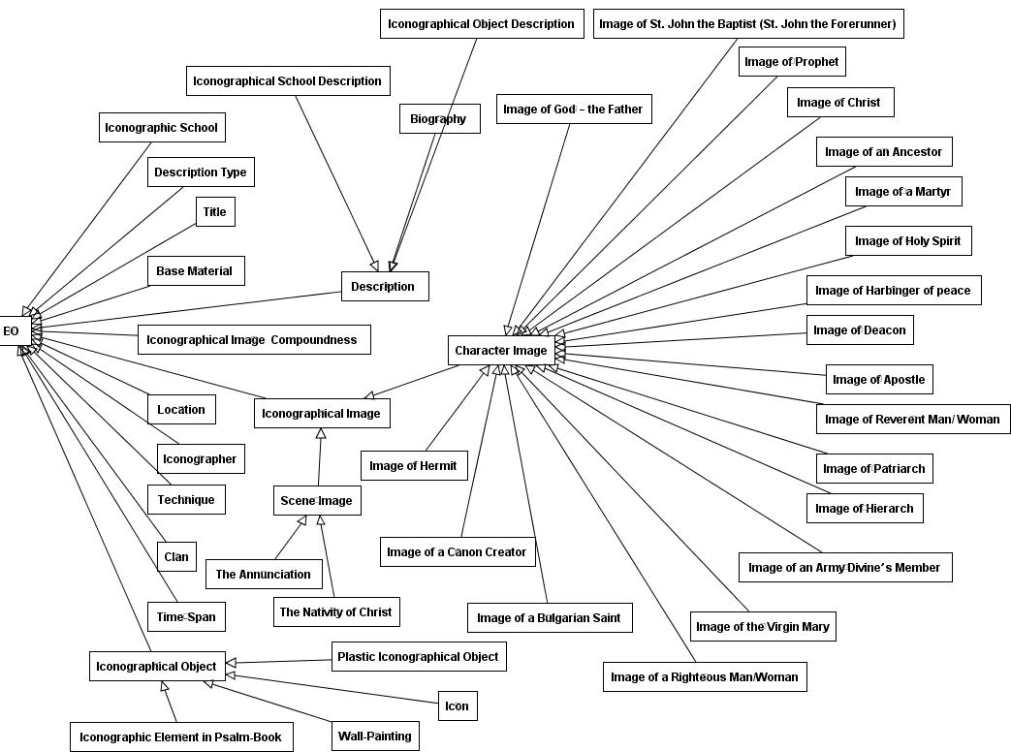

Figure 4: Main concept types in the Ontology of Bulgarian Iconographical Object

The concepts were provided with definitions satisfying domain experts and knowledge engineers. Description and scope of each concept type are also included. The ontology vocabulary is developed in Bulgarian and English.
The interpretations of the iconographical knowledge do not have to be considered isolated from the standards and specifications in the field of cultural information representation because the goal is to maximize the reusability and portability of the designed ontological model. Therefore, as a Top-level ontology of the described we use CIDOC Conceptual Reference Model (http://cidoc.ics.forth.gr) that is developed by International Committee for Documentation of the International Council of Museums as a ”object-oriented domain ontology" for expressing the implicit and explicit concepts in the documentation of cultural heritage. The OBIO is a specialization of the higher level CIDOC Conceptual Reference Model.

Implementation of the Ontology of Bulgarian Iconographical Objects
In the LOGOS project we adopt the Conceptual Graphs formalism for domain ontology creation. The LOGOS Authoring Studio Ontology Management Tool, called CoGui, is a Conceptual Graphs-based tool that provides functionality to create and maintain concepts and relation vocabularies, constraints, rules, facts graphs, pattern graphs, prototypic graphs, etc. necessary for the annotation process of the raw audiovisual materials. It is developed by the team from the Montpellier Laboratory of Computer Science, Robotics and Microelectronics and is used by knowledge managers to create and maintain the core concepts and relations of the Bulgarian iconography ontology. Several prototypic and pattern graphs (description templates) for annotation and semantically indexing of iconographical objects, authors and iconographic schools are also created.
The annotation aiming to create LOGOS DOs from raw iconographical content, extracted from the “Virtual encyclopaedia of Bulgarian iconography” will start soon. It will be realized through the LOGOS Authoring Studio Content Description Tool. The main steps in the process are the following: At first, the annotators have to load a media or a DO of his working list (This option is available for edit an existing “editable DO”). When the media is loaded it displays in the working convenient format for logically segmentation and description through the OBIO domain ontology and the developed description templates (the ontology has also to be loaded). Semantic description of the objects and/or their segments is made graphically using conceptual graphs. Additional forms are provided for the classical metadata capture. The produced descriptions are stored in a digital object repository using mix of Cogitant XML (CGXML) and MPEG-7 format – METS format. The created DO will be used for the creation of the LOGOS learning objects.

References

Arapi P., Moumoutzis N., Mylonakis M., Christodoulakis S. (2007). A Framework and an Architecture for Supporting Interoperability between Digital Libraries and eLearning Applications, In the proceedings of the DELOS Conference on Digital Libraries, Tirrenia, Pisa, Italy
Bloom, B., D. Krathwohl (1965). Taxonomy of Educational Objectives: The Classification of Educational Goals, Handbook I, Cogniyibe Domain, Longman, New York
IEEE Personal and Private Information (2002). Draft 8 Specification, Available online: http://edutool.com/papi/
IMS Learner Information Package Specification V1.0.1 (2005). Available online: http://www.imsglobal.org/profiles/
Pavlov, R. and D. Paneva (2006), Toward Ubiquitous Learning Application of Digital Libraries with Multimedia Content, Cybernetics and Information Technologies, vol. 6, № 3, pp. 51-62.
Pavlov, R., L. Pavlova-Draganova, L. Draganov, D. Paneva (2006). e-Presentation of East-Christian Icon Art, In the proceedings of the Fourth HUBUSKA Open Workshop “Semantic Web and Knowledge Technologies Applications”, Varna, Bulgaria, pp. 42-48.
Pavlova-Draganova, L., V. Georgiev, L. Draganov (2007). Virtual Encyclopaedia of Bulgarian Iconography, International Journal “Information Technologies and Knowledge”, vol.1, №3, pp. 267-271.
Pemberton, L., S. Faliahkhair, R. Grifits, M. Kanerva, G. Feher (2007). Combining Learning Affordances in Cross Platform Learning Environments, In the proceedings of EDEN 2007 Annual Conference, Naple (under print)

Appendix 1: Variants of the “Access-on-demand for studying of East-Christian culture and art” scenario

Scenario situation A

Nikola is a bachelor student on Mural painting in the Faculty of Fine Arts, University of Veliko Tarnovo.
Nikola uses the most recent technologies. He owns a portable computer and has broadband Internet access at home and at college. He has a smartphone/PDA, capable of accessing Internet or WAP sites, or even displaying DVB-H broadcasts.
During his third year in the university Nikola follows a course on East-Christian Iconography that includes practical exercises in icon paining. As a course project he has to paint an icon on a specific theme. He knows that in the region of Veliko Tarnovo there are many churches and monasteries where remarkable icons and mural paintings are preserved.
Nikola’s friend Bogomil is a bachelor student at the Faculty of Orthodox Theology, University of Veliko Tarnovo. He also uses modern technologies. He can use a computer, but he doesn’t have one at home.
Nikola is a registered end-user of the LOGOS system and has already described his profile using the available user interfaces. In the profile he includes data about his preferences, educational background and experience, learning goals, individual learning style, device used, etc. The system uses this information to create a personalised adaptive knowledge stream; for example, it requires Nikola to set the level of initial knowledge, educational background in the domain of iconography, so as to adapt the content of the courseware objects and present them with the corresponding complexity and degree of detail. He declares himself advanced in the area and the system presents the most complete versions of the courseware objects. Nikola also names his learning goals, so that the system will be able to recommend the most suitable learning materials later on. Besides, Nikola intends to use the Internet and a mobile device to access the LOGOS environment. By entering these data he enables the envitonment to choose and fetch the most appropriate versions and formats of the learning resources according to the supplying channels. The environment tracks the user’s behaviour—the courseware objects chosen, the path of their study, the time they took, the most recently visited learning resource etc., so that Nikola can continue his study on his next visit where he left off last time. This information is also sent to educationists and courseware developers, so that conclusions can be drawn on the students’ needs and interests and the LOGOS repositories for learning and courseware object can be supplemented and updated appropriately.
Nikola decides to visit some churches with historical and artistic significance together with Bogomil, who knows the religious foundation of the area and its specialized theological aspects. Moreover, Bogomil is interested in aspects of religious history and different iconographic interpretations of the Bible events, in particular icons with multipictural scene presentation.
Before the travel Nikola uses his laptop and accesses the LOGOS environment to explore learning materials about the best icon specimens and their locations in Veliko Tarnovo churches.
While travelling to Arbanassi, Nikola uses his smartphone to show to Bogomil the chosen specimens and their locations.
Nikola and Bogomil visit the church of the Nativity with the chapel of St John the Baptist in Arbanassi and use the smartphone to see additional learning objects about virtual specimens on the chosen subject and periods that are not exposed in the church. Then they visit other churches in the Veliko Tarnovo region, which are also outstanding repositories of icons and mural paintings, and read more useful information on the smartphone.
While travelling back, Bogomil and Nikola learn again. They watch the actually broadcasted digital knowledge about Veliko Tarnovo icon art on the smartphone.
Nikola has special interests not only in iconography, but also in the field of traditional technological tools and methods in Bulgarian icon creation. Using a personal computer at his university, Nikola traces some traditional technological tools and methods in Bulgarian icon creation, available in the LOGOS environment as a learning course. He also accesses the platform to show the remarkable icons he visited today to his project manager, and they discuss the specific theme of the icon.
At home Nikola systematizes his observation and the discussion on his laptop.

Scenario situation B

Desislava is an MSc student of Ethnology at the Department of History, University of Sofia.
She uses the most recent technologies. She owns portable computers and has broadband Internet access at home and at their universities. She has a smartphone/PDA, capable of accessing Internet or WAP sites, or even displaying DVB-H broadcasts.
Desislava is working on her master’s thesis, which is devoted to the place, role and images of the Orthodox saints in traditional Bulgarian culture (late 18th to mid-20th century). One of the fundamental problems in her work is the mutual influence between the traditional popular views on the saints and the canonical depictions of saints in Bulgarian iconography in the chosen period.
For this purpose she needs to study the art of the various schools of iconography and seek and research the existence of elements related to traditional folk culture in icons and murals, including costumes, details of the interior, architecture etc.
A colleague of Desislava’s has recommended the LOGOS environment as a source of educational materials about East-Christian culture, Bulgarian traditional culture and cultural heritage. Desislava decides to register to and use the LOGOS environment for the observation of Iconographic school’s art and receive knowledge. She also fills her personalized profile, describing his background.
The LOGOS system constructs learning and courseware objects by using the different knowledge repositories. Two of them are the multimedia digital libraries—“Virtual Encyclopedia of Bulgarian Iconography” and “Bulgarian Ethnographic Treasury”. Of exceptional value for the student is the possibility to search and sort courseware objects, including iconographic artefacts from different schools, locations, periods, or any combination of such criteria (special services offered by the LOGOS platform). The possibility to magnify an image enables the ‘reading’ of the details of the composition and makes for a clearer and more particularly structured questionnaire for field work with respondents and on-site observation of artefacts. Desislava was instantly taken with the LOGOS environment, having also found in it certain fundamental mythologemata on the origin and functioning of the various iconographic schools, also a good basis for comparison with their local variations and interpretations. Over a few days she explores the major iconographic centres, studies the available artefacts and learning objects and collects data using her laptop.
After becoming closely acquainted with the educational materials, she decides to visit Bansko. During the travel she accesses the LOGOS environment on her smartphone and marks the best icon specimens and their locations. She has taken her laptop along for comparative observations, which will help her make the research more concrete. Desislava visits some churches in the Bansko region, where remarkable icons and mural paintings are preserved, takes photos and searches information in the LOGOS environment. At home the Desislava systematizes her observations on the laptop and processes her photographs.

This work is partially funded by the LOGOS project “Knowledge-on-Demand for Ubiquitous Learning” FP6 IST-4-027451.

